**PowerCLI script to configure vRealize Automation 7.x IaaS Components**

**Overview**

The purpose of this document is to provide a process to reduce the amount of time it takes to deploy vRealize Automation by automating the deployment of Windows VMs needed for installation of vRealize Automation 7.x IaaS components.

**Step 1: Create a template for vRealize Automation IaaS Components**

Create a New Windows VM (from template or from scratch).

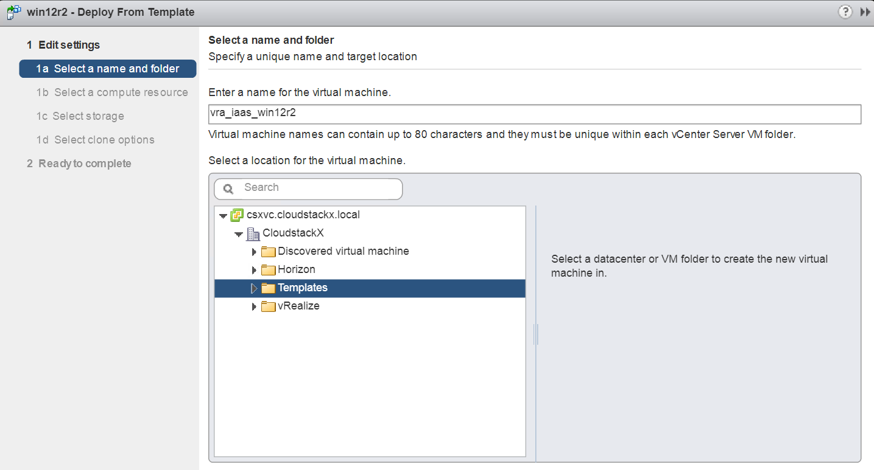

Select compute resources.

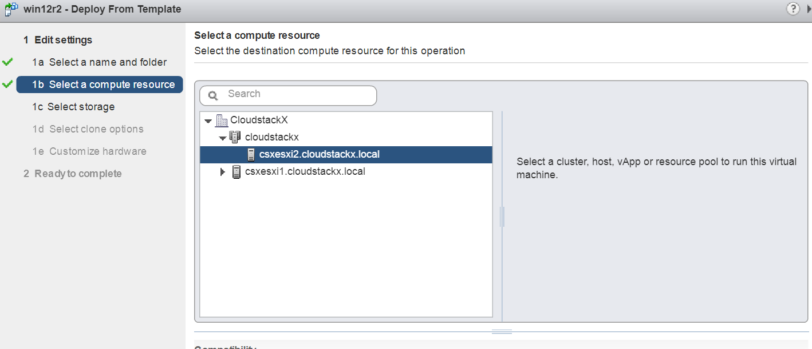

Select datastore.

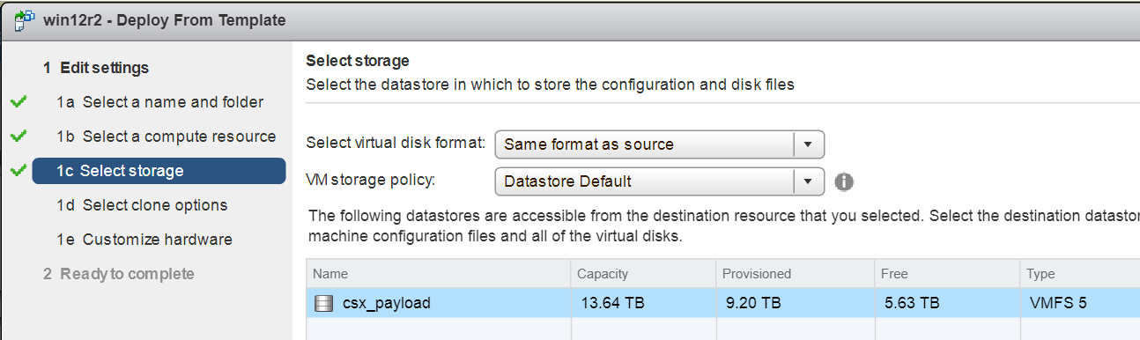

Select all clone options.

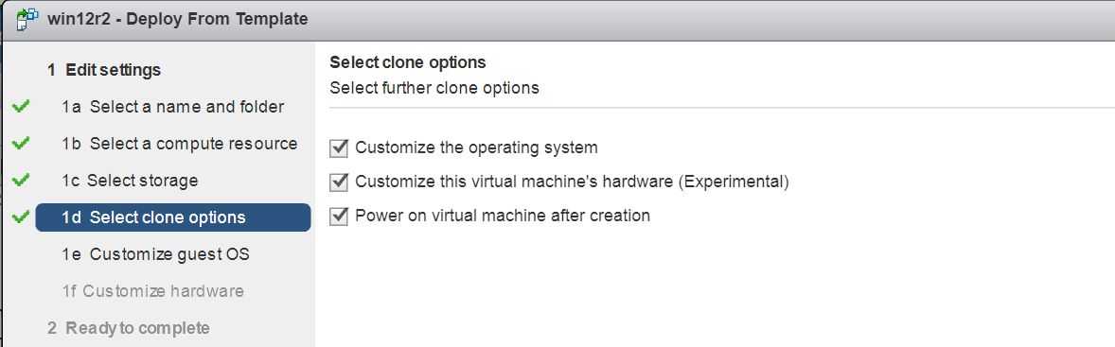

Create (or use) a windows customization spec. Recommended: apply Sysprep, apply license key and join to a domain.

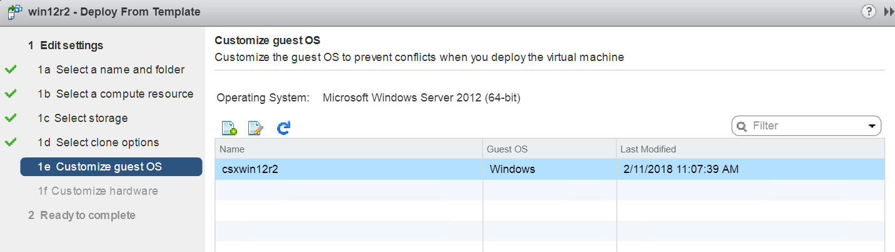

Configure required hardware settings (see Installation and Configuration guide for details).

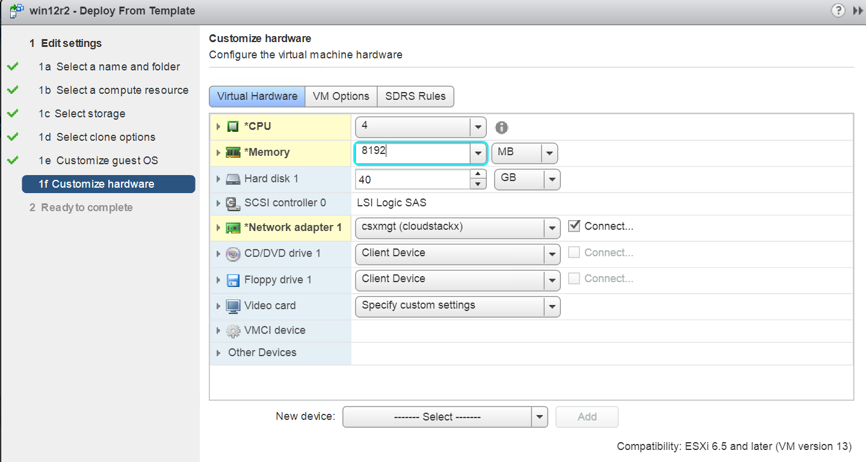

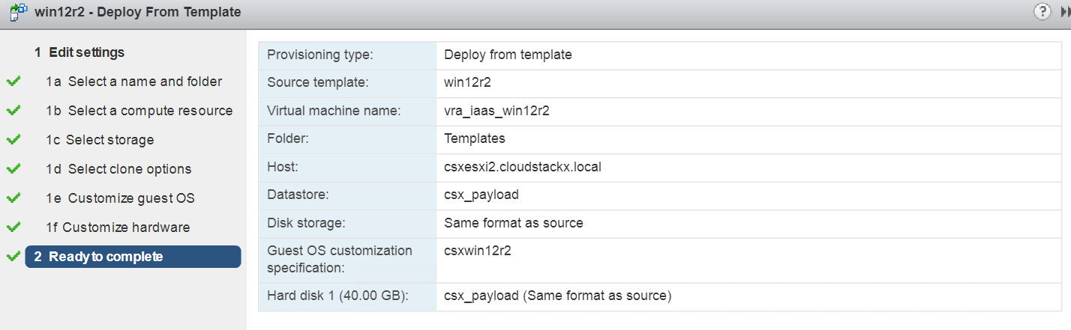

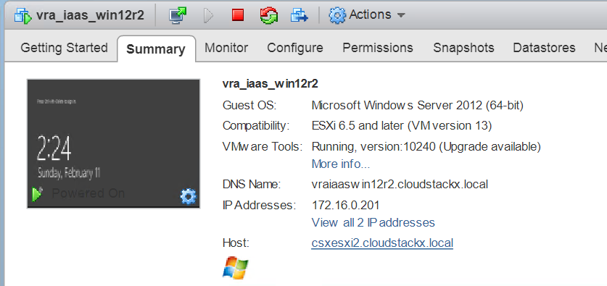

Login using AD service account.

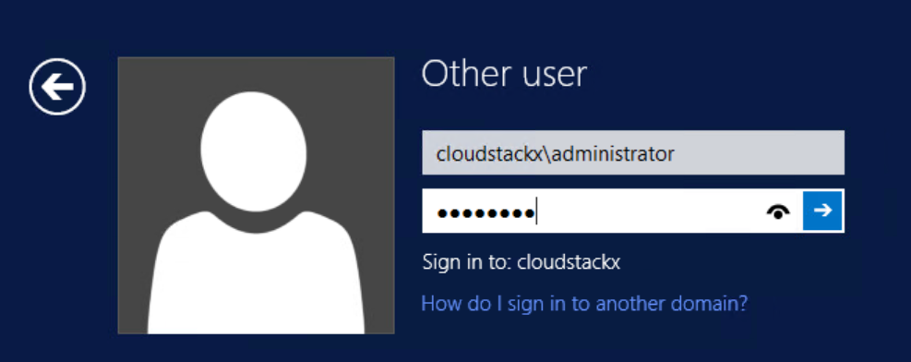

Ensure firewalls are turned off and remote management/desktop is Enabled.

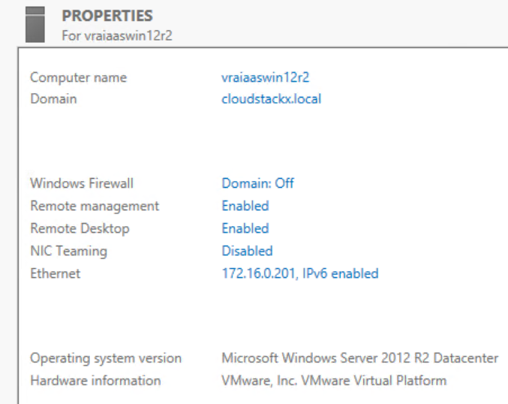

Download Java x64 JDK.

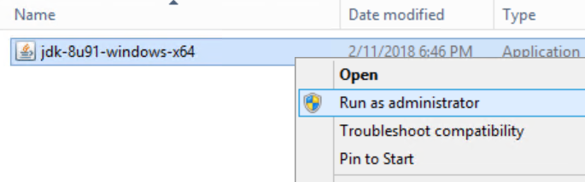

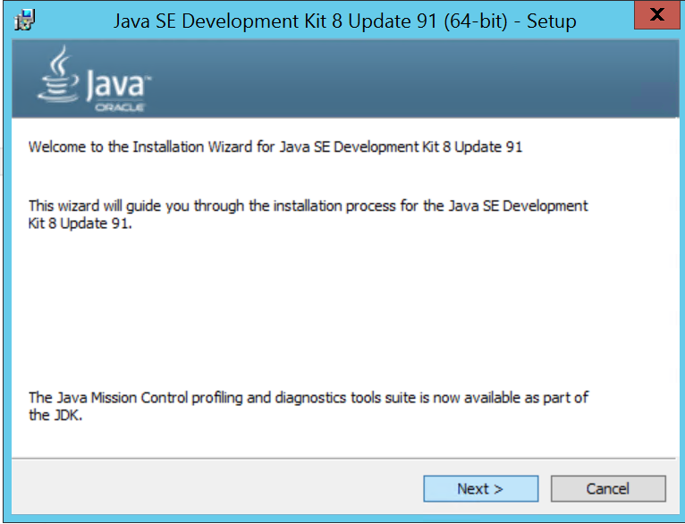

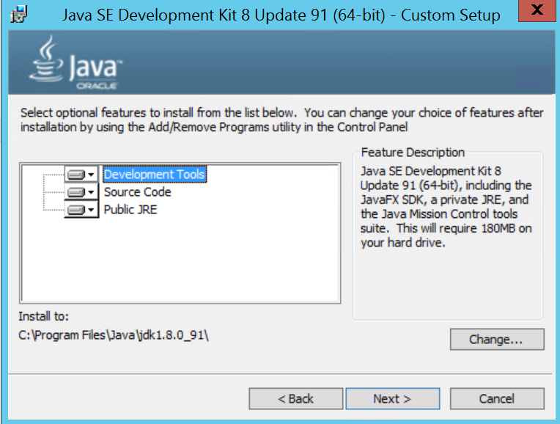

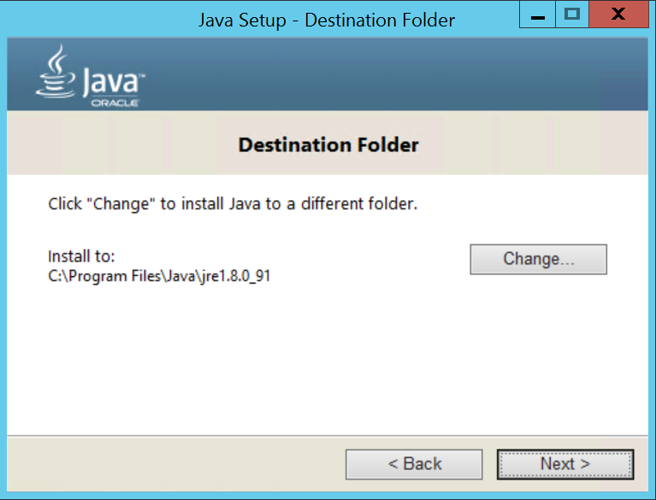

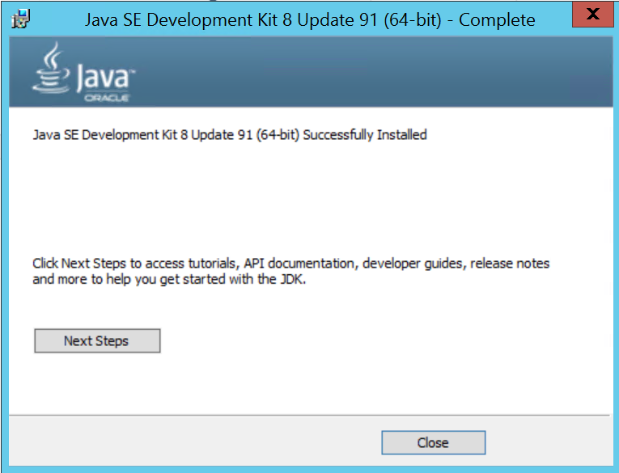

Restart the VM.

Configure the JAVA_HOME environment variable.

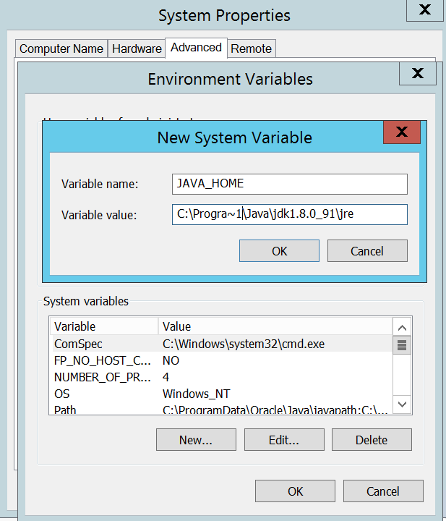

Validate using **set** command.

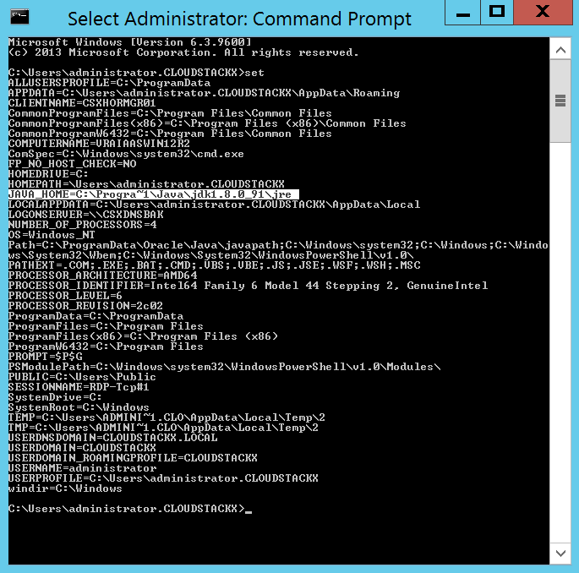

Shut down VM and convert to template.

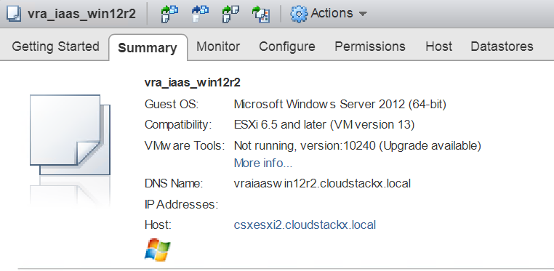

**Step 2: Deploy Windows VMs using PowerCLI script**

Download and install PowerCLI on a desktop or jump host. For details on how to install and configure PowerCLI see the following: <https://blogs.vmware.com/PowerCLI/2011/06/back-to-basics-part-1-installing-powercli.html> or see the vSphere PowerCLI installation guide.

Download **pscli_installVRAIaaSVMs_Win12R2.ps1** from <https://github.com/boconnor2017/boc-pub/blob/master/vRealize/pscli_installVRAIaaSVMs_Win12R2.ps1>



Open the script using an editor. Configure the input parameters accordingly. (NOTE: vRealize Automation reference architecture supports several sizes, each of which requires a different number of VMs. For further details please see the vRealize Automation Installation and Configuration Guide. Recommended: enter IP addresses into your enterprise IPAM and DNS entries prior to running the script.)

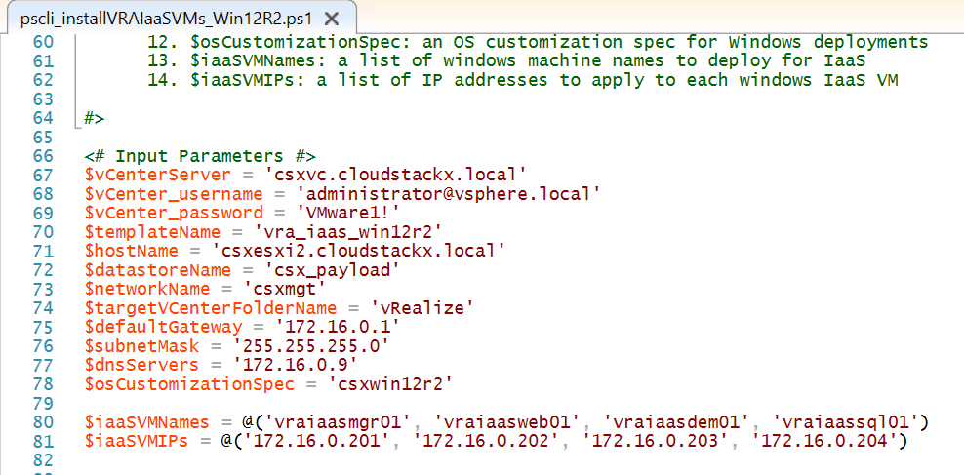

Start PowerCLI and navigate to the directory where you downloaded the **pscli_installVRAIaaSVMs_Win12R2.ps1** script. Run the script.

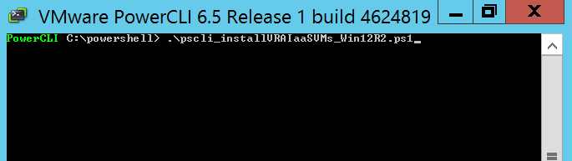

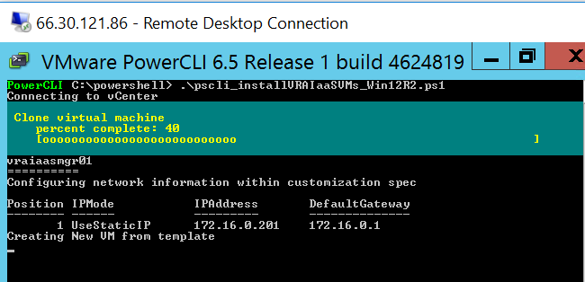

When the script is finished, the vRA IaaS components should be ready for installation.

